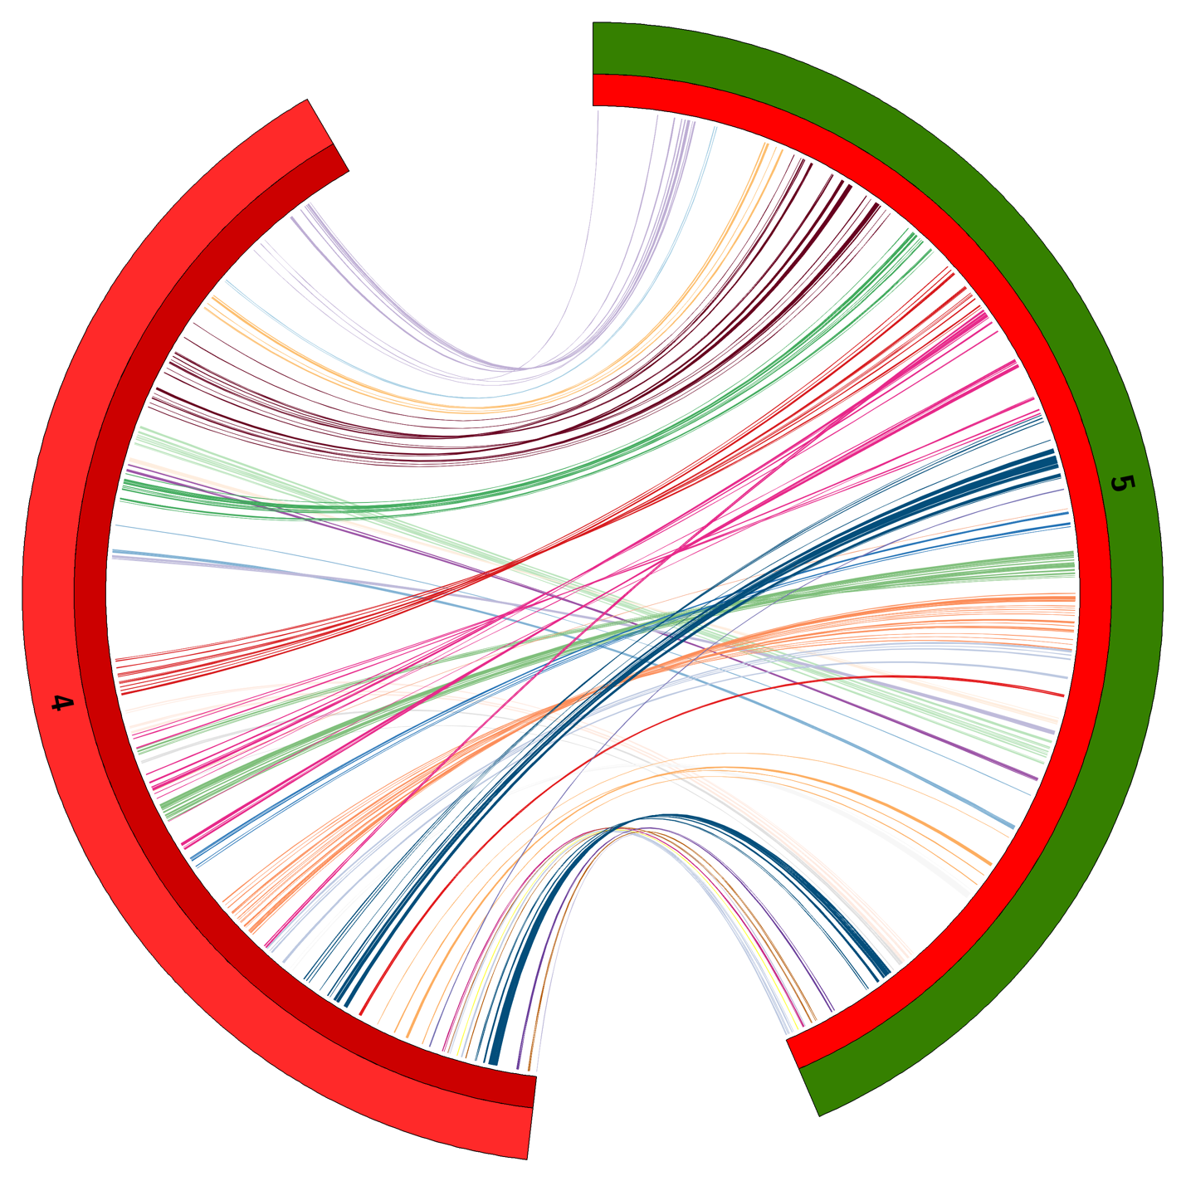Platyfish Chr4 (left) and Killifish Chr5 (putative sex chromosome, right). Lines connect 1-to-1 orthologs (obtained by reciprocal blast). Ortholog lines are colored by reference genome scaffold ID (same color=found in same contig in killifish). The relative positions of the mapped killifish chr5 genes is determined by averaging scaffold positions between the male and female map. We found that the final Chr5 is much more like the map generated from the female informative markers. Male and female maps were combined by allmaps (see next figure)

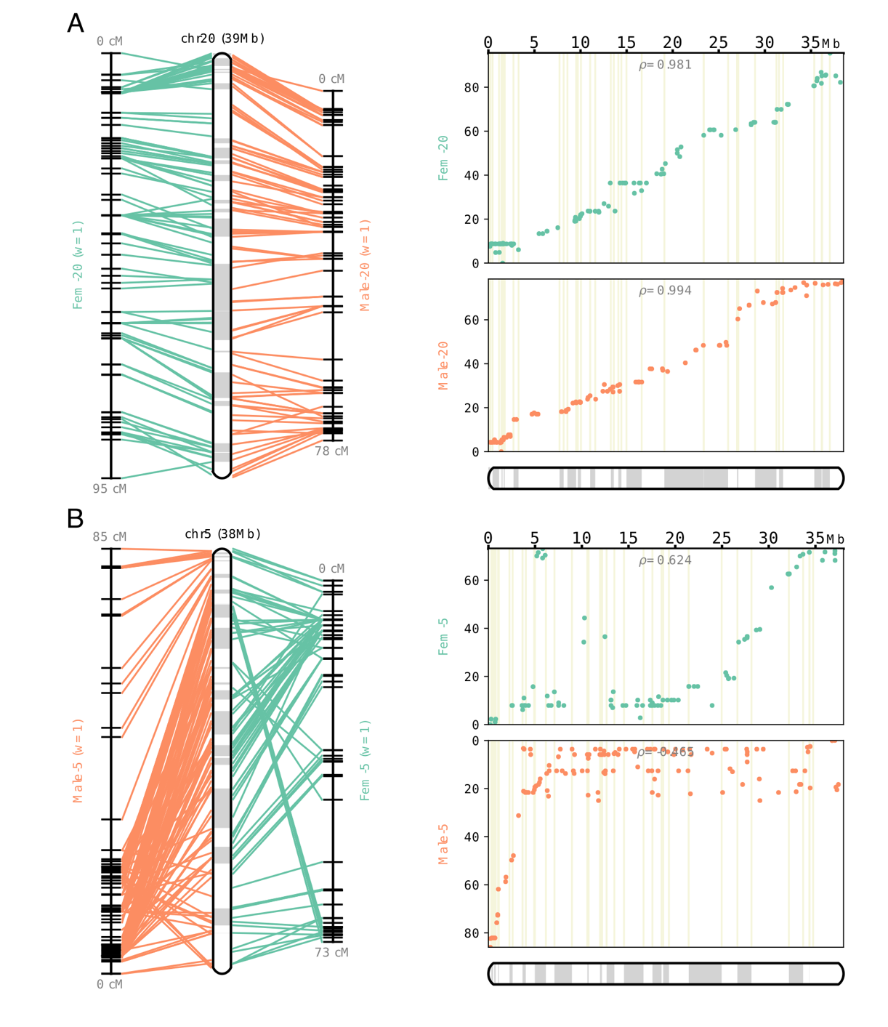

**S1. Maximization of collinearity in the final consensus map from male and female informative markers (NOTE: B is the killifish sex chromosome)**. ALLMAPS output for the merged independently mapped markers that are informative for recombination in the male are in orange and blue-green for female markers. Left figures indicate the placement of markers in each sex specific map with the resulting consensus map in the center to indicate the final genome scaffold placement (alternating in white and grey along the chromosome). Plots on the right correlate the original centi-morgan (cM) position for markers (y-axis) with the resulting position in the consensus map. A) High collinearity between the sex-specific maps (ex. LG20, top left) results in a higher correlation with the new position in the consensus map (ex. LG20, top right). B) Low collinearity between the male and female map had greater differences between the maps (ex. LG5, bottom left) and has been previously associated with sex determination (Reid et al. 2016).

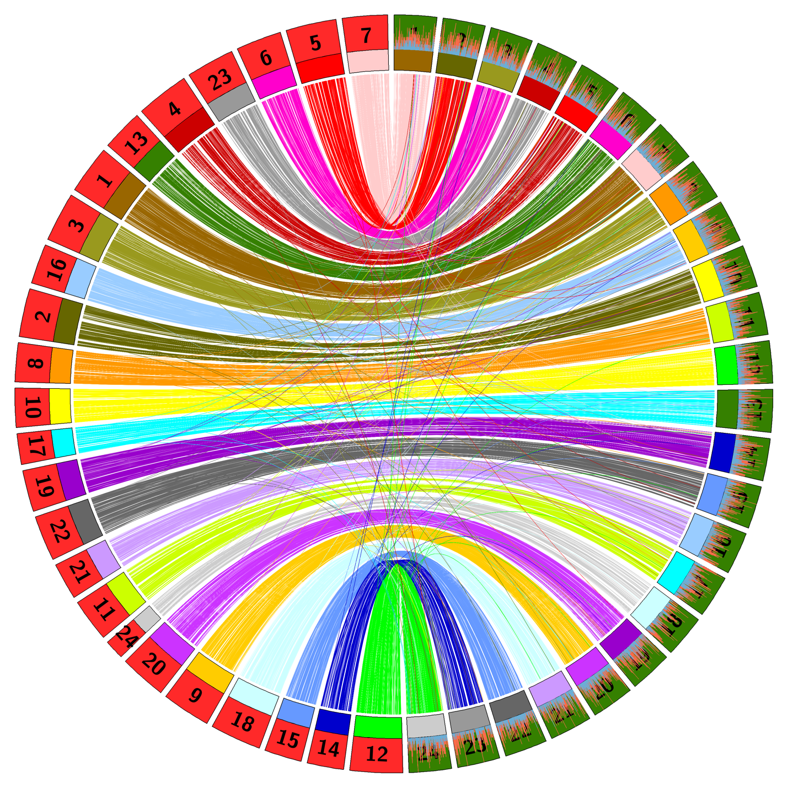Platyfish (left, red) and killifish (right, green) chromosomes. 1-to-1 orthologs colored by killifish chromosome ID. Sorry for the labels on kfish. Clockwise from 12 o’clock is Chr1 to 25 at 6 o’clock.

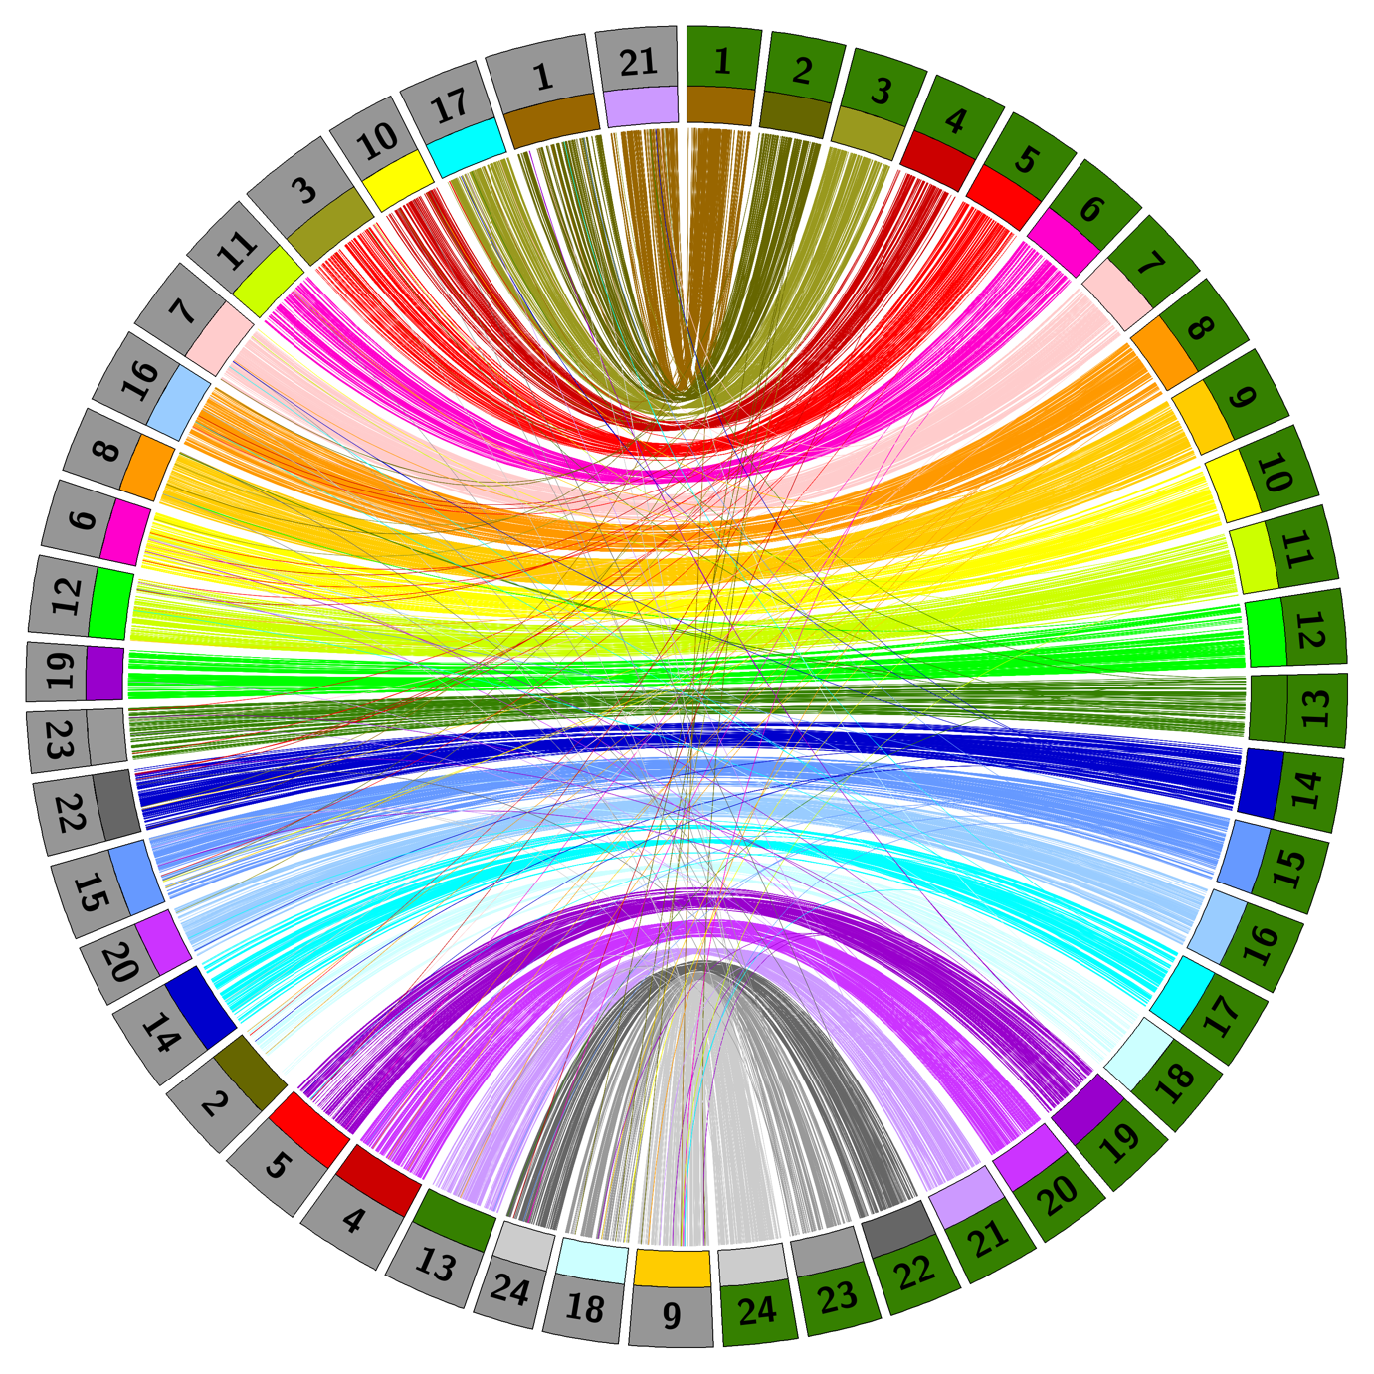

Medaka (left, grey) and killifish (right, green) chromosomes. 1-to-1 orthologs colored by killifish chromosome ID.

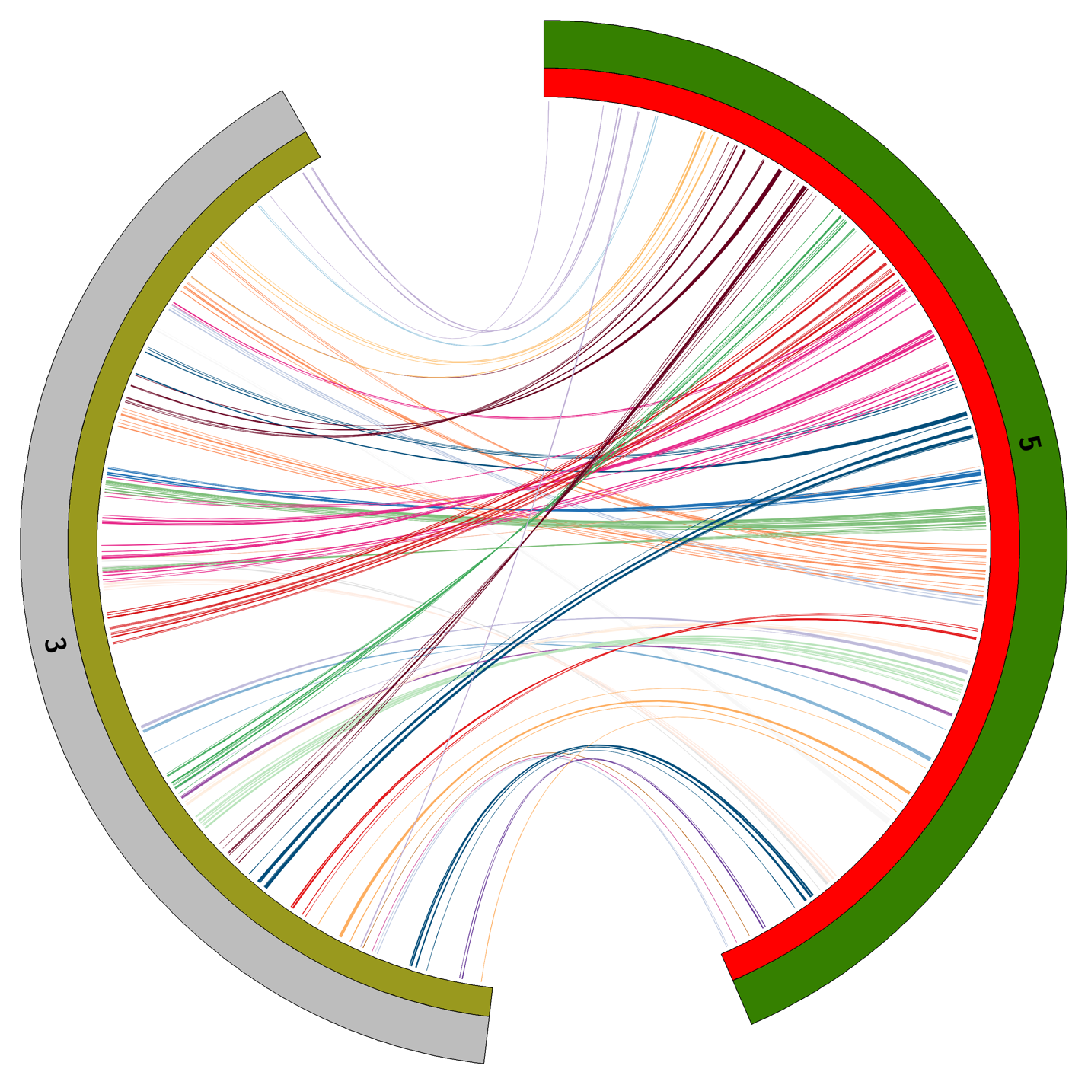

Medaka’s Chr3 with the Killifish Sex chromosome.